EVANSVILLE CARE CENTER |  March 2025  |  |  |  |  |  |  | CALENDAR IS SUBJECT TO CHANGE
Sunday | Monday | Tuesday | Wednesday |  | Thursday | Friday |  | Saturday
 |  |  |  |  |  |  |  | 1 IDITAROD BEGINS  10:00- LEFT, RIGHT, CENTER  1:00- IDITAROD FUN FACTS  3:00- COFFEE TIME  3:30- MOVIE “SNOW DOGS” & POPCORN  ONE ON ONE VISITS
2  CHURCH SERVICES ON CHANNEL 43.1  1:00- POLKA SPOTLIGHT  3:00- COFFEE TIME   | 3  9:00- SPA DAY  11:00- HEALTHY HEARTS CLUB  11:30- DINNER TRIVIA  3:00- COFFEE TIME  3:30- JEOPARDY | 4  10:00- ASH WEDNESDAY SERVICE WITH PASTOR BRAD  11:00- HEALTHY HEARTS CLUB  12:00- FAT TUESDAY FEAST  1:00- BOOKMOBILE  2:00- BINGO  3:00-   4:00- FAITH CHURCH SERVICE | 5  10:00- DEVOTIONS WITH BARB & FRIENDS  10:00- ASH WEDNESDAY SERVICE WITH FATHER THEIS  11:00- HEALTHY HEARTS CLUB  1:00- TRIVIA  3:00- COFFEE TIME  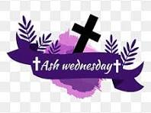 |  | 6  7:45- WAFFLES WITH BRANDON  9:00- BEAUTY SHOP  10:00- WORDS IN WORDS  11:00- HEALTHY HEARTS CLUB  2:00- BINGO  3:00- COFFEE TIME  4:00- REACH CHURCH SERVICE | 7  9:30- CATHOLIC COMMUNION  10:00- DISCUSSION GROUP  11:00- HEALTHY HEARTS CLUB  2:00- MUSIC WITH CURTIS & LORETTA SIMONET  3:00- COFFEE TIME  4:00- ST. ANN’S CATHOLIC MASS |  | 8  1:00- POLKA SPOTLIGHT  2:00- MOVIE & SNACKS  3:00- COFFEE TIME
9 DAYLIGHT SAVINGS TIME  CHURCH SERVICES ON CHANNEL 43.1  1:00- POLKA SPOTLIGHT  3:00- COFFEE TIME  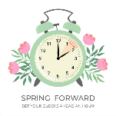 | 10  9:00- SPA DAY  11:00- HEALTHY HEARTS CLUB  11:30- DINNER TRIVIA  2:00- RESIDENT COUNCIL MEETING  3:00- COFFEE TIME  3:30- WHEEL OF FORTUNE | 11  10:00- HYMNS WITH PASTOR NATE  11:00- HEALTHY HEARTS CLUB  2:00- BINGO  3:00- COFFEE TIME  4:00- FAITH CHURCH SERVICE | 12 HAPPY BIRTHDAY LARRY!  10:00- NAME THAT TUNE WITH MARYANN  11:00- HEALTHY HEARTS CLUB  1:00- TRIVIA  3:00-LARRY’S BIRTHDAY PARTY  3:30- ST. PATRICK’S DAY BRACELET |  | 13  9:00- BEAUTY SHOP  10:00- WORDS IN WORDS  11:00- HEALTHY HEARTS CLUB  2:00- THE HOLMQUISTS  3:00- COFFEE TIME SERVING GIRL SCOUT COOKIES  4:00- REACH CHURCH SERVICE | 14  9:30- CATHOLIC COMMUNION  10:00- DISCUSSION GROUP  11:00- HEALTHY HEARTS CLUB  2:00- BINGO  3:00- COFFEE TIME  4:00- ST. ANN’S CATHOLIC MASS |  | 15  10:00- PENNY ANTE  1:00- SHORT STORIES  3:00- COFFEE TIME  3:30- MOVIE & POPCORN  ONE ON ONE VISITS
16  CHURCH SERVICES ON CHANNEL 43.1  1:00- POLKA SPOTLIGHT  3:00- COFFEE TIME | 17 HAPPY BIRTHDAY DARLENE!  9:00- SPA DAY  11:00- HEALTHY HEARTS CLUB  11:30- DINNER TRIVIA  12:00- CORNED BEEF & CABBAGE  2:00- MUSIC WITH NEIL & ORLO  3:00- DARLENE’S BIRTHDAY PARTY  4:00-VIRTUAL VACATION TO IRELAND   | 18  10:00- COMMUNION WITH PASTOR BRAD  11:00- HEALTHY HEARTS CLUB  1:00- BOOKMOBILE  2:00- BINGO  3:00- COFFEE TIME  4:00- FAITH CHURCH SERVICE | 19 HAPPY BIRTHDAY MARVELLA!  10:00- COLORING CLUB  11:00- HEALTHY HEARTS CLUB  1:00- TRIVIA  2:00- NATIONAL LET’S LAUGH DAY  3:00- MARVELLA’S BIRTHDAY PARTY  4:00- GOSPEL SING-ALONG |  | 20 FIRST DAY OF SPRING  9:00- BEAUTY SHOP  10:00- WORDS IN WORDS  11:00- HEALTHY HEARTS CLUB  12:00- INDOOR PICNIC  3:00- ICE CREAM SOCIAL  4:00- REACH CHURCH SERVICE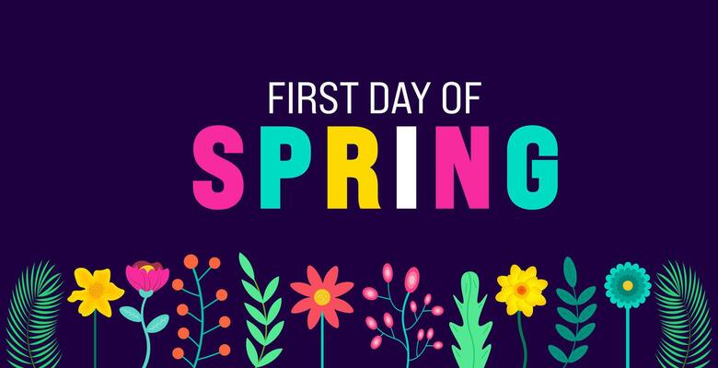 | 21  9:30- CATHOLIC COMMUNION  10:00- DISCUSSION GROUP  11:00- HEALTHY HEARTS CLUB  2:00- BINGO  3:00- COFFEE TIME  4:00- ST. ANN’S CATHOLIC MASS |  | 22  1:00- POLKA SPOTLIGHT  2:00- MOVIE & SNACKS  3:00- COFFEE TIME
23  CHURCH SERVICES ON CHANNEL 43.1  1:00- POLKA SPOTLIGHT  3:00- COFFEE TIME | 24  9:00- SPA DAY  11:00- HEALTHY HEARTS CLUB  11:30- DINNER TRIVIA  3:00- COFFEE TIME  3:30- WORDSCAPES | 25  10:00- HYMNS WITH PASTOR NATE  11:00- HEALTHY HEARTS CLUB  2:00- BINGO  3:00- COFFEE TIME  4:00- FAITH CHURCH SERVICE | 26  10:00- COLORING CLUB  11:00- HEALTHY HEARTS CLUB  1:00- TRIVIA  2:15- AGE TO AGE  3:00- MONTHLY BIRTHDAY PARTY  4:00- YOU PICK MUSIC PLAYLIST |  | 27  9:00- BEAUTY SHOP  10:00- WORDS IN WORDS  11:00- HEALTHY HEARTS CLUB  3:00- COFFEE TIME  4:00- REACH CHURCH SERVICE | 28  9:30- CATHOLIC COMMUNION  10:00- DISCUSSION GROUP  11:00- HEALTHY HEARTS CLUB  2:00- BINGO  3:00- COFFEE TIME  4:00- ST. ANN’S CATHOLIC MASS |  | 29  10:00- LEFT, RIGHT, CENTER  1:00- SHORT STORIES  3:00- COFFEE TIME  3:30- MOVIE & POPCORN  ONE ON ONE VISITS
30  CHURCH SERVICES ON CHANNEL 43.1  1:00- POLKA SPOTLIGHT  3:00- COFFEE TIME | 31  9:00- SPA DAY  11:00- HEALTHY HEARTS CLUB  11:30- DINNER TRIVIA  2:00- GRIEF SUPPORT GROUP  3:00- COFFEE TIME | MARCH BIRTHDAYS:  LARRY- 12TH  DARLENE - 17TH  MARVELLA- 19TH |  |  |  |  | MONTHLY AND DAILY ACTIVITY CALENDAR LOCATED ON CHANNEL 10.1, PLEASE CHECK DAILY ACTIVITY BOARD LOCATED IN THE DAY ROOM FOR ANY UPDATES OR CHANGES

